Hands On Data Lab Implementation
Data Analyst Internship Task 2 of 6
Programme dates 10 October 2026 to 5 December 2026

Objective and environment
The lab establishes a reproducible Python workspace and demonstrates data loading, manipulation, cleaning, visualization and summary analysis. Use Python 3.10 or newer, create a virtual environment and install requirements.txt. Start Jupyter from the extracted project folder and open notebook 02.

Installation and execution
Windows commands are python -m venv .venv, .venv\Scripts\activate, python -m pip install -r requirements.txt, python run_all.py and jupyter notebook. On Linux or macOS use source .venv/bin/activate. The bundled CSV supports offline reruns after dependency installation. outputs/results.json records the executed package versions.

Practical exercises
Load the CSV with pandas.read_csv, inspect shape and dtypes, compute describe, filter BMI above 30 and summarize target scores. Use NumPy for mean, median and standard deviation; use Pandas for filtering, groupby and CSV export. Plot a histogram and scatter chart with Matplotlib and label axes with the actual variables.

Cleaning demonstration
The full source has zero missing cells and zero duplicate rows. To demonstrate cleaning, a copy of the first 12 rows is intentionally changed: one BMI becomes missing and one record is duplicated. The dirty copy has 13 rows. Remove the duplicate and fill missing BMI with the remaining median, giving 12 rows and no missing BMI values. This copy is clearly distinguished from the real source.

Results and checks
The full audited data contain 442 rows and 11 columns. The mean target is 152.1335 and median target is 140.5. Compare before and after row counts for the lab copy and confirm the full source is not overwritten. Exported clean and dirty examples make transformations reviewable.

Files and conclusion
Notebook 02 and src/analysis.py provide the implementation. data/lab_dirty_example.csv and lab_clean_example.csv hold the cleaning evidence. The lab produces labelled charts and reusable tabular outputs, establishing a working environment for subsequent tasks.

References and reproducibility
https://scikit-learn.org/stable/modules/generated/sklearn.datasets.load_diabetes.html
Dataset notes and original study attribution are in data/SOURCE.md. The README explains setup, task mapping and submission. Report values are computed outputs, not proof of clinical validity.

Visual evidence
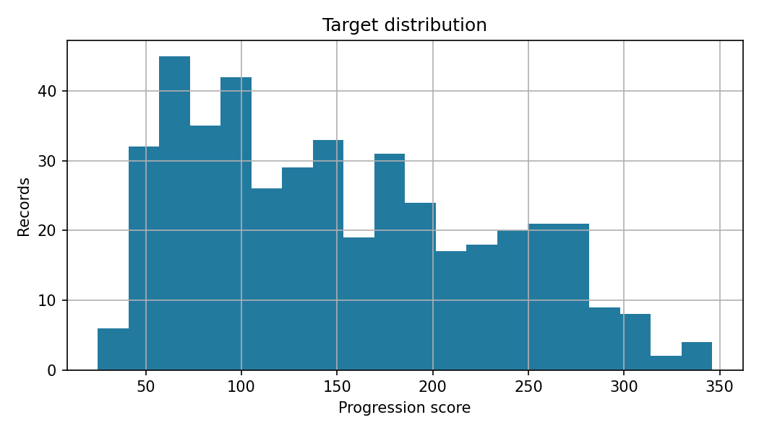
Target distribution from the complete source dataset.

Computed evidence
Rows 442 Missing cells 0 Duplicate rows 0
Target mean 152.13 Target median 140.50
Complete tables and chart generation are available in outputs and src.

